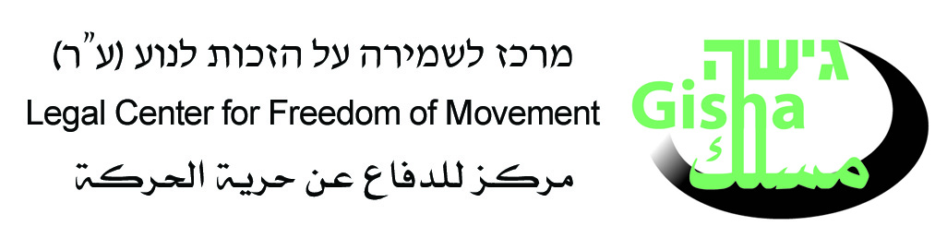

Commercial Closure: Deleting Gaza’s Economy from the Map
July 2007

Gisha - Legal Center for Freedom of Movement

- Israel’s closure policy is destroying Gaza’s business sector and denying its residents the right to live in dignity.
- Local production is paralyzed; at least 75% of factories have shut down.
- 85% of Gaza resident are already dependent on humanitarian aid.
- The closure is turning 1.4 million people into charity dependents.

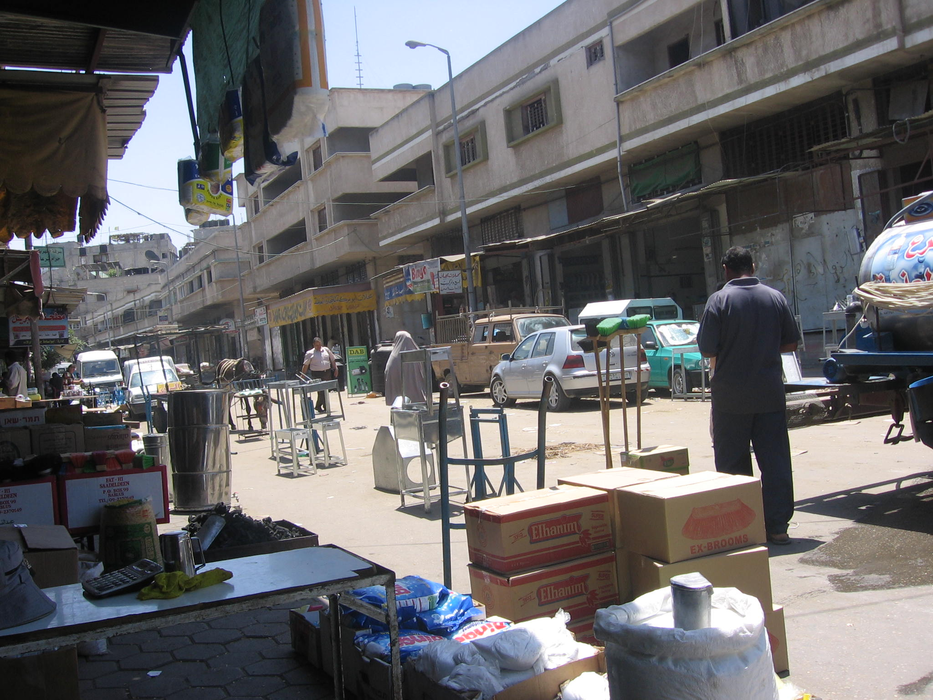
The market square is empty. Alzawieh Market, Gaza, June 2007
Photo by Gisha

- Policy of Commercial Paralysis

In the aftermath of the Hamas takeover of Gaza, Israel closed the crossings into and out of the Gaza Strip, and the economic boycott became complete. The Israeli Customs Authority instructed agents not to transfer commercial goods to Gaza, with the exception of a limited amount of products, defined as for humanitarian use only.

Fuel, essential supplies and medicines are transferred in small quantities by humanitarian organizations, mostly through the Kerem Shalom crossing (which is significantly limited in terms of capacity), in order to prevent an immediate humanitarian crisis.

Data compiled by Gisha, a human rights organization protecting the right of Palestinian residents to freedom of movement, show that Gaza's industry is collapsing. Out of the 3,900 factories in Gaza producing food, pharmaceuticals, construction materials, wood, paper, craftwork, engineering materials, metals, plastics and rubber, more than 2,900 factories have ceased to produce.

- 75% of Gaza's factories have shut down because of the closure of the borders. The rest of the factories are operating on a limited basis, on borrowed time, until the stocks of raw materials are exhausted;
- 85% of Gaza residents are already dependent on food aid – and the number is growing.
- A high-ranking industrialist in Gaza: "In another week, all production will cease";
- There is a serious shortage of raw materials, including flour and sugar for household and industrial consumption, and prices of raw materials have risen between 15% and 34%;
- Approximately 30,000 factory workers stand to lose their jobs (factory employees constitute 10% of those working in Gaza, and on average, each worker supports a family of seven. In Gaza, unemployment stands at 35%);
- Israel erased from its computers the customs code used to identify goods entering Gaza and issued orders not to allow any imports into Gaza, with the exception of humanitarian goods, such as donations of food, medicine and medical equipment. According to a letter from Mr. Reuven Meltzer, Deputy Head of the Israeli Customs Administration, "Cargo intended for the Gaza Strip will not be released until further notification. Requests to clear goods intended for Gaza will be blocked by the computer system." The implications: Gaza is closed to the importation of goods.

Israel's working assumption is that choking Gaza's economy and closing its borders to the passage of people will achieve the political objectives it wants. According to this theory, political objectives are to be achieved by exerting pressure on 1.4 million women, men and children, whose suffering is to bring out the desired change – toppling Hamas control in Gaza. In reality, a policy of collective punishment is being imposed upon 1.4 million people, in violation of international humanitarian law and, in effect, in clear contradiction of Israel's interests.
This policy is destroying the business sector, creating a new welfare regime in Gaza, and turning growing numbers of Gaza residents into dependents on international welfare agencies and religious charities.
As of today, 87% of Gaza residents live below the poverty line. The opportunity to earn a living with dignity and to build a properly-functioning society is disappearing. According to the chairman of Israel's Association of Industrialists, Shraga Brosh, "the economic boycott on the Gaza Strip …will result in a humanitarian disaster, fueling flames and leading to deterioration of the security situation – a situation that will be destructive to the Israeli economy."

2. Ban on Passage of Goods –the Voice of Despair

"The situation in which there is no chance of importing raw materials into Gaza paralyzes Palestinian industry. Israel is not punishing the government; instead it is punishing the people. As members of the private sector we are paying the price. We hope that Israel will not punish the entire population; Israel must understand that we have basic needs that must be met. There are a lot of people that have been hurt by this closure, lost their jobs, and their livelihood."

Mr. Ali Al-Hayak, Director, Palestinian Federation of Industry

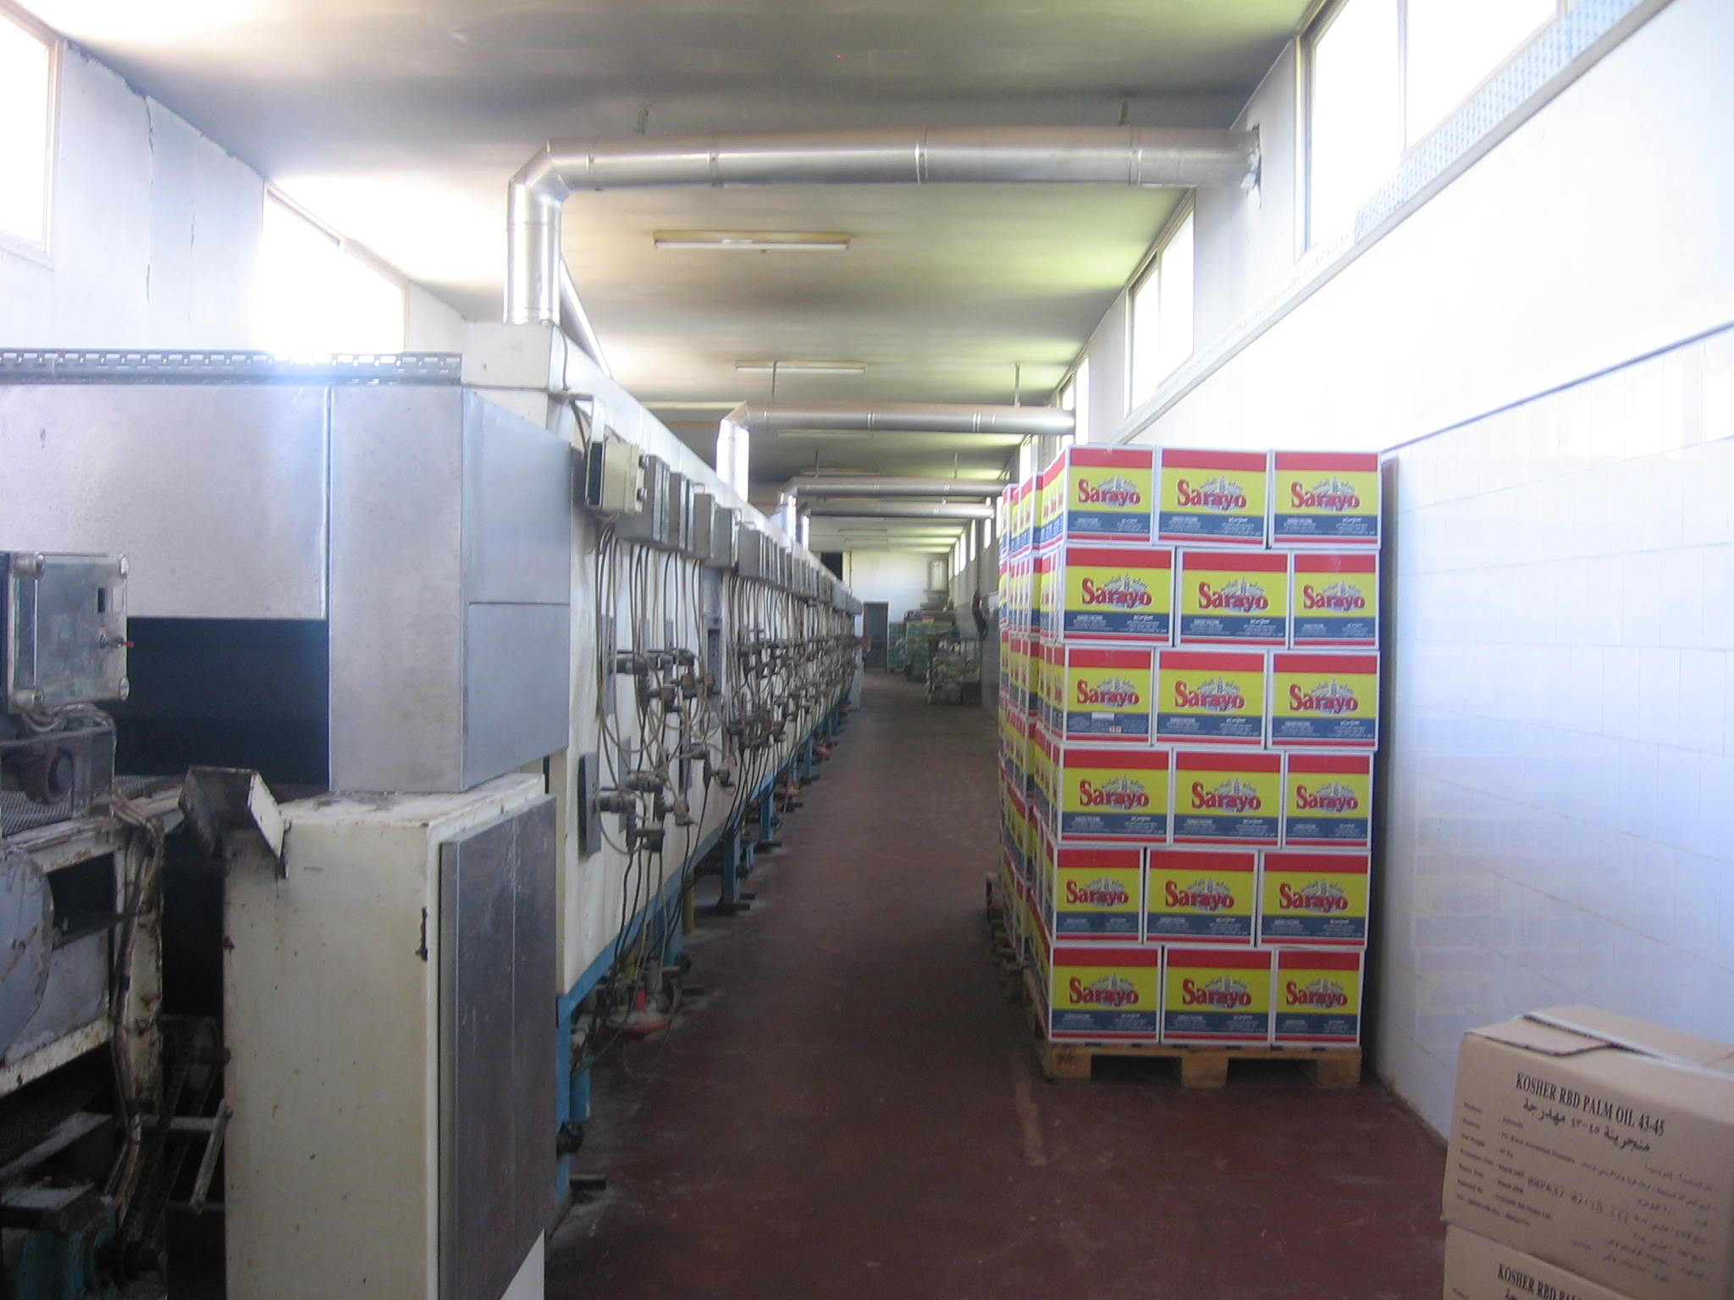
Sarayo Sweets Factory, Gaza – No raw materials; no production.
Photo by Gisha

Israel completely controls the importation of goods into Gaza and exercises significant control over the exit of goods from Gaza abroad and to the West Bank. Israel does not allow the transfer of goods to or from Gaza via the sea, the air or the Rafah Crossing between Gaza and Egypt. The only option for Gaza residents is to transfer goods through the crossings with Israel, primarily via Karni crossing.

On June 12, 2007, Israel closed Karni crossing – Gaza's primary artery of commerce. Israel has since permitted the importation of humanitarian goods through the Kerem Shalom, Sofa and Erez Crossings, but their capacities are very limited. Humanitarian aid organizations warn of shortages of basic humanitarian supplies, because the daily amount of essential supplies entering the Gaza Strip is less than Gaza's daily needs.

Due to the uncertainty regarding supply of food, there has been a steep increase in the price of food products in markets, including an increase of approximately 34% in the price of flour, an increase of 30% in the price of powdered milk, and an increase of 20% in the price of rice.

"The prices are impossible, it's murder, where will we find the money for food? Things are usually difficult, anyway, but now the prices are getting more expensive. How will we eat? I walked in the oppressive heat from Majraka [distance of approximately 8 kilometers], because I don't have the money to pay for carfare. Every shekel I spend on travel is one shekel less to buy food for the children."

Fatma, 47 years old, customer at the Alzawieh Market in Gaza

As noted, once the borders were closed and the order was given not to clear goods intended for Gaza, it became impossible to transfer goods that are not strictly humanitarian: food, medicine, and medical equipment. In the first two weeks of the closure alone, Palestinian importers accrued $1.5 million in debt for fines paid for the use of rented containers that were stuck, and each day the charges increase. Significant losses are also incurred from the breach of supply contracts and the paralysis of Gaza's industry. Additional losses are being incurred from damage to goods stored in warehouses for extended periods of time.



Production lines halted. Factory in Gaza, June 2007.
Photo by Gisha.

"The Gaza Strip has been economically removed from the map and from Israel's agenda. If they erase the customs code for Gaza, what is left?

Mr. Majdi Khalil, General Director, Palestinian Shippers' Council

Gaza's factories are collapsing. Producers have long suffered from difficulties in importing raw materials and exporting finished products and unreliable electricity supplies, due to the destruction of Gaza's power station by the Israeli Airforce in June 2006. Most of the factories that exported goods shut down even before the current closure of borders, because the frequent closures of Karni Crossing in the past disrupted business. However, now, even factories producing goods for local consumption are finding it very difficult to operate.

"Today I closed my factory due to the shortage of cocoa, which is important for all of the products that the factory produces. Not that I have an abundance of other raw materials, but cocoa is the first to be used up. We need 133 kinds of raw materials to operate. I employ about 350 workers in my factory, approximately 85 on a monthly salary, and the rest on a daily wage basis. I do not know how I will pay for them, and therefore, today I shut the factory and asked them to stay home. The border closure has forced me to lose the clients with whom I work.

Mr. Mohammed Al-Talabani, Owner of Al-Auda biscuit factory, Gaza

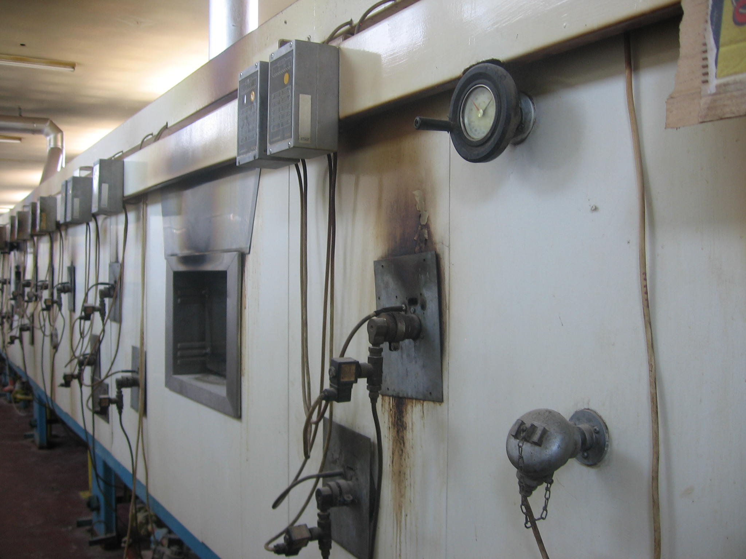

Al-Auda biscuit factory closes due to a shortage of cocoa, and 350 employees, supporting 2,450 dependents – are thrown out of work.
Photo by Gisha

Agricultural export, too, which had survived in Gaza prior to the border closure, has been paralyzed. As of June 12, 2007, farmers cannot sell their vegetables, flowers, and other produce to Israel, the West Bank, and other countries. These farmers are losing the livelihood that was to support them and their families.

"As long as the borders are closed, it is impossible to manage a business. Businesspeople need freedom of movement. They need to be able to travel, to meet with businesspeople from around the world, to import and export from Gaza. We are now starting to see factories that have been shut down. My estimation is that from now on, we will see massive layoffs of workers from local industries … The siege prevents us - businesspeople who can invest in Gaza and create something – from acting. We can achieve good things in Gaza, but these limitations are crippling our ability to do so. The siege blocks us, those who wield influence and can help, and it causes businesspeople and those with capital to leave. We have the ability to provide work to individuals, to give some of them the opportunity to live with dignity. We can create prosperity in Gaza if only the borders would open regularly, and regular commercial activity would be permitted.

Mr. Faysal Shawwa, Director of the Palestinian Businessmen's Association

3. Legal Framework: Collective Punishment

Under international law, as the occupying power in Gaza and the West Bank, Israel is obligated to provide for the needs of the civilian population in Gaza, to guarantee their rights, and to facilitate the functioning of normal life in Gaza, to the extent that the matter is under its control.

Israel's obligations are especially strong because of its control over Gaza's air space, territorial waters, and land borders with the outside world, including significant control over the border between Egypt and Gaza. Such control renders civilians in Gaza subject to decisions made by Israel. Israel's control over Gaza's borders imposes an obligation to allow Gaza residents – who are permitted to transfer goods only via Gaza's crossings with Israel – to receive and send goods, in order to maintain a properly functioning economy.

Denying Gaza residents the ability to live in dignity, to lead normal lives, to work and support themselves and their families violates Israel's obligations under international humanitarian and human rights law and Israeli law. Israel is required to permit the passage of food, clothing, medicine, and medical equipment, and to facilitate civilian life in Gaza through all means at its disposal.

Israel is also obligated, to the extent possible, to permit civilians in Gaza to lead normal lives. Normal life is not just food and water, but rather dignified human existence, the possibility of continuing to earn a livelihood, including permitting factories in Gaza to operate and to supply incomes to their workers and dependents. Indeed, Israel must also protect the rights of Gaza residents to work, to strive to achieve an adequate standard of living and to continuously improve their living conditions.

Instead, Israel has adopted a policy of collective punishment, in violation of international humanitarian law, which explicitly provides that no person shall be punished for a deed that he did not commit.

4. Recommendations

In response to an appeal from Gisha asking that Gaza's borders be opened, Israel's Defense Ministry replied as follows:

"Regarding Karni Crossing, we repeat and emphasize that the crossing was closed beginning June 12, 2007 in light of an announcement by the Palestinian side, that because of the internal conflicts in the Strip, they were not capable of operating it, in addition to their inability to defend against terrorist activities at the crossing and to prevent the destruction of goods entering the Strip, as a result of the lack of a party responsible for managing the crossing on the Palestinian side."

Gisha recognizes that the changes in internal power within Gaza may necessitate changes in the coordination mechanism for opening the crossings, which thus far had been operated, on the Palestinian side, by security forces answerable to the President of the Palestinian Authority, Mahmoud Abbas. The partial opening of the crossings for passage of humanitarian aid shows, that even after the take-over of key positions in Gaza by Hamas, it is possible to open Gaza's crossings and to permit Gaza residents the passage of goods necessary to live in dignity. Responsibility for finding a new method of coordination, if necessary, rests with Israel, as the power exercising control over the passage of goods via air, sea, and land. Responsibility for facilitating and assisting in that coordination lies with Palestinian leaders in Gaza and the West Bank, if necessary with the assistance of international actors.

Recommendations for Immediate Implementation:

- For Israel:
  - To open Karni Crossing, the commercial crossing between Israel and Gaza, and to work with Palestinian and/or international actors – irrespective of political beliefs – who have the capability to coordinate opening the crossing from the Gaza side;
  - To renew customs clearance for commercial goods intended for Gaza;
  - To permit Gaza residents to export goods via the crossings;
  - To open the borders of Gaza to passage of persons.
- For leaders of the Palestinian Authority in Gaza and the West Bank: To act immediately to coordinate the opening of Gaza's commercial crossings, through a commitment to meeting the needs of Gaza residents – irrespective of political beliefs.
- For Egypt and the international community: To offer immediate assistance to efforts to reopen Gaza's borders to import and export.

For further details, please contact Gisha at:

P.O. Box 20111
Tel Aviv 61200
Tel: +972-3-6244120
Fax: +972-3-6244130
www.gisha.org

Rafah crossing, between Gaza and Egypt, was closed beginning June 10, 2007. Karni Crossing between Israel and Gaza, Gaza's lifeline through which commercial goods are transferred, was closed beginning June 12, 2007. Erez Crossing, the crossing for travelers between Gaza and Israel, was closed on June 14, 2007 and since then has opened only for humanitarian exceptions.
See letter from Reuven Meltzer, Deputy Director of the Customs Authority, Israeli Shippers, dated June 20, 2007 (on file with the authors).
According to the Palestinian Federation of Industry. Approximately 75% of the factories that were operating on the eve of Karni's closing on June 12, 2007 have ceased production.
According to data by the World Food Program.
Letter from Deputy Head of the Israeli Customs Administration, Mr. Reuven Meltzer, to Mr. Pintor, Director of the Umbrella Organization of Customs Agencies and the International Shippers from June 17, 2007 (on file with the authors).
See "Situation Report", United Nations Office for the Coordination of Humanitarian Affairs, June 20, 2007, available at www.ochaopt.org.
For details on Israeli control over Gaza borders, see Gisha's position paper: Disengaged Occupiers: The Legal Status of Gaza, January 2007, pp. 32-49, available at www.gisha.org.
According to the agreement that allows for the opening of Rafah crossing, in principle, goods can be exported via Rafah crossing. However, since June 2006, Israel has not allowed for the regular opening of Rafah crossing, and it has not been possible to develop a direct channel for exports between Gaza and Egypt. The same agreement prohibits importing goods via Rafah. Israel allows for the entrance of goods via Kerem Shalom crossing, which is located in Israel, next to the triangular border between Gaza, Egypt and Israel. See Disengagement Danger, aforementioned footnote.
See, for example, a report on the humanitarian situation in Gaza, June 20-27, 2007, the UN Office for the Coordination of Humanitarian Affairs, June 28, 2007, available at www.ochaopt.org.
See the UN report noted in the aforementioned footnote.
According to Mr. Majdi Khalil, General Director of the Palestinian Shippers Association.
On the control Israel exercises in Gaza and the legal obligations that it creates, see Gisha's position paper, Disengaged Occupiers, supra note Error: Reference source not found.
Geneva Convention Relative to the Protection of Civilian Persons in Time of War, 1949, Articles 23, 55 and 59.
Hague Convention Respecting the Laws and Customs of War on Land, 1907, Article 43.
International Covenant on Economic, Social and Cultural Rights, 1966, Articles 6 and 11.
Hague Regulations, supra note Error: Reference source not found , Article 50, and Fourth Geneva Convention, supra note Error: Reference source not found, Article 33.
Letter from Koby Gerzwolf, Assistant to the Coordinator of Government Activities in the Territories, to Adv. Noam Peleg of Gisha, June 27, 2007 (on file with authors).

